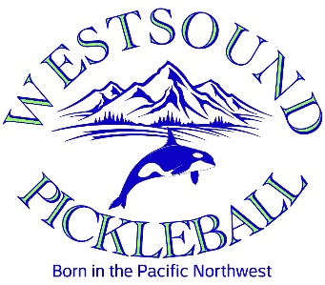

Westsound Pickleball Community (WPC) is a 501c3 group of pickleball enthusiasts serving Kitsap County. We are seeking sponsors for our 2nd annual Bremerton Blackberry Blast pickleball tournament to be held 8/30, 8/31, 9/1 at Bremerton Lions Park.

Our event expects over 750 spectators, families, friends, and players over the Labor Day Weekend coinciding with the Bremerton Blackberry Festival. With over 260 members and over 800 social media members, last year’s 2-day event brought over 300 people from all over the world.

Your sponsorship provides funding for:

* Youth development programs
* Skills and Drills Training for our members, local schools, and Olympic College
* Pickleball Facilities Development to reach all ages and abilities

Logos will appear on all flyers, banners, advertisements, our website on www.westsoundpickleball.com and nationally on pickleballbrackets.com. Donations and logos need to be received prior to July 1, 2024, for us to best market your company.

Our sponsorship levels are:

* ACE ($1,000 and above)
* RALLY ($500 - $999)
* LOB ($250 - $499)
* VOLLEY ($249 and below)

Pickleball is making a difference in our community! Please consider partnering with Westsound Pickleball Community, as we continue to serve Kitsap County. Email contact information, donation level and any questions to [westsoundpickleball@gmail.com](mailto:westsoundpickleball@gmail.com).

We hope to see you at the 2024 Bremerton Blackberry Blast tournament! Paddles UP, let’s have fun with pickleball!

Jane Clark

WPC Sponsorship Chair